**Lab 07**

**Exercise**

1. **Create a secret message containing your name and roll number along with “The World is Real. Be good to yourself.” Embed the file ‘secretmessage.txt‘ inside the cover file ‘coverfile.jpg‘ and name the output stegofile ‘hiddenmessage.jpg‘. What is the full command you would use to do this?**

**Command: steghide embed -cf coverfile.jpg -ef secretmessage.txt -sf hiddenmessage.jpg**

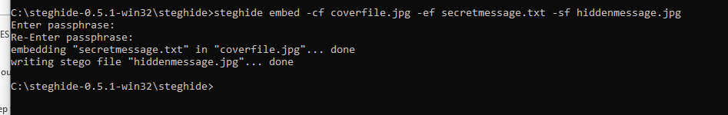

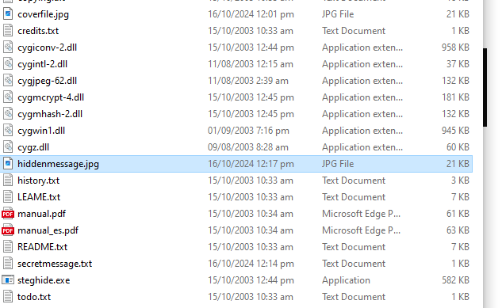

1. **Extract the secret message send by your fellow student. What is the message and how to extract it?**

**Command: steghide extract -sf hiddenmessage.jpg**

